**2D Self Driving Car ReadMe**

This is a JavaScript Self Driving Car that is trained with neural networks with no libraries. This project shows you how artificial neural networks work by comparing them with our brains’ neural networks. This project allows you to visualize the neural network by seeing it used in real time. In this project we implement the driving mechanics, build the environment, simulate some sensors, detect collisions, and how to make the car control itself using a neural network.

**Setup & Installation Requirements**

* JavaScript
* Visual Studio Code

**References:**

<https://youtu.be/Rs_rAxEsAvI>

**Project Workflow:**

**Car Driving Mechanics:**

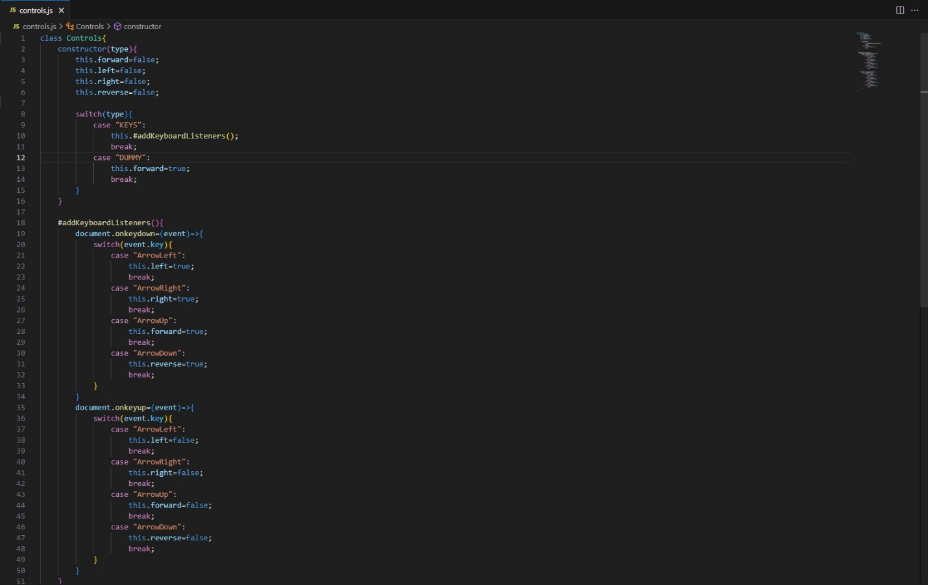

**Defining the Road:**

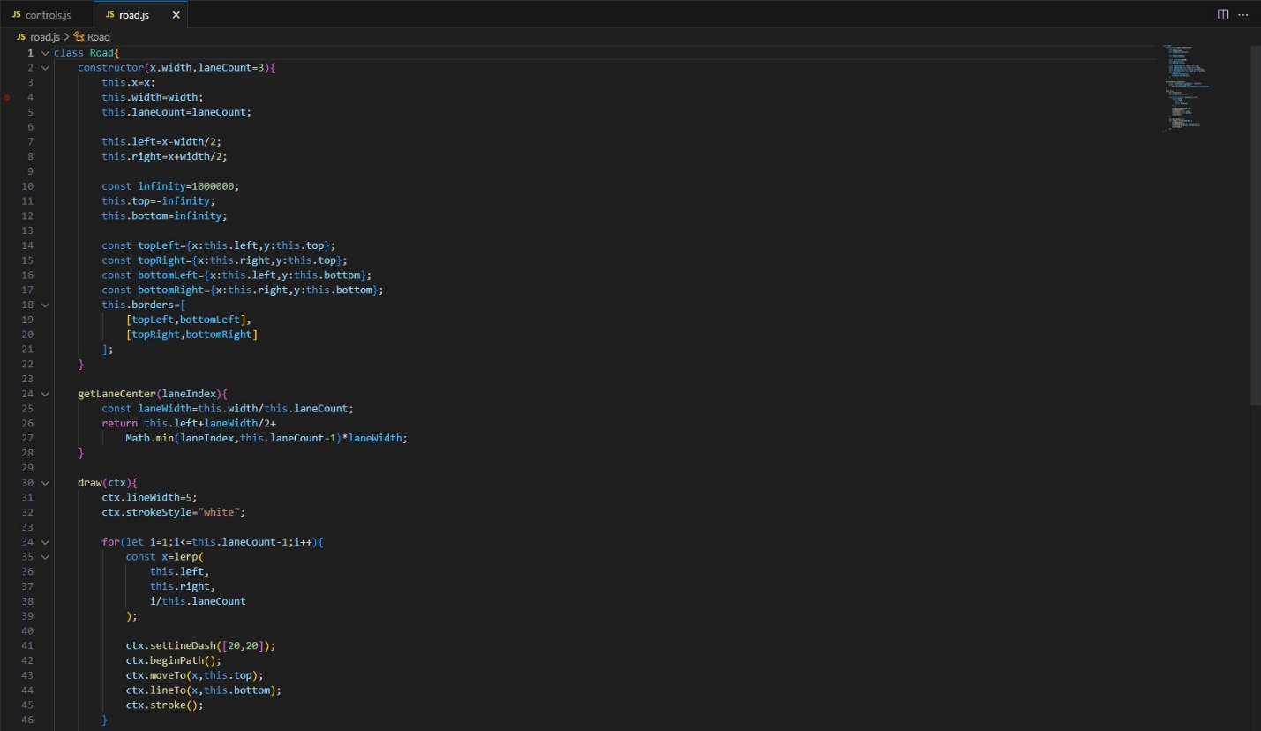

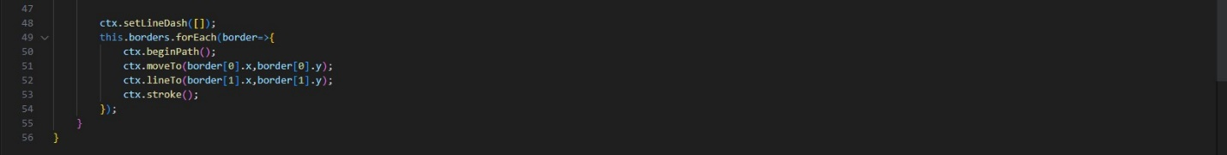

**Artificial Sensors:**

The purpose of the Sensor class is to simulate sensor readings for the car, allowing it to perceive its environment.

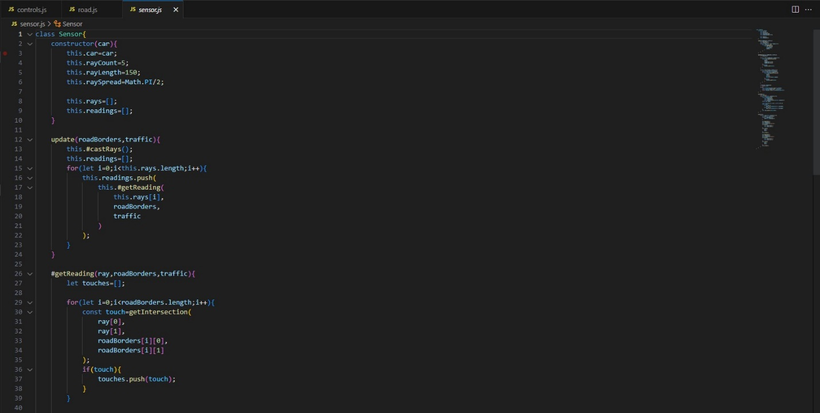

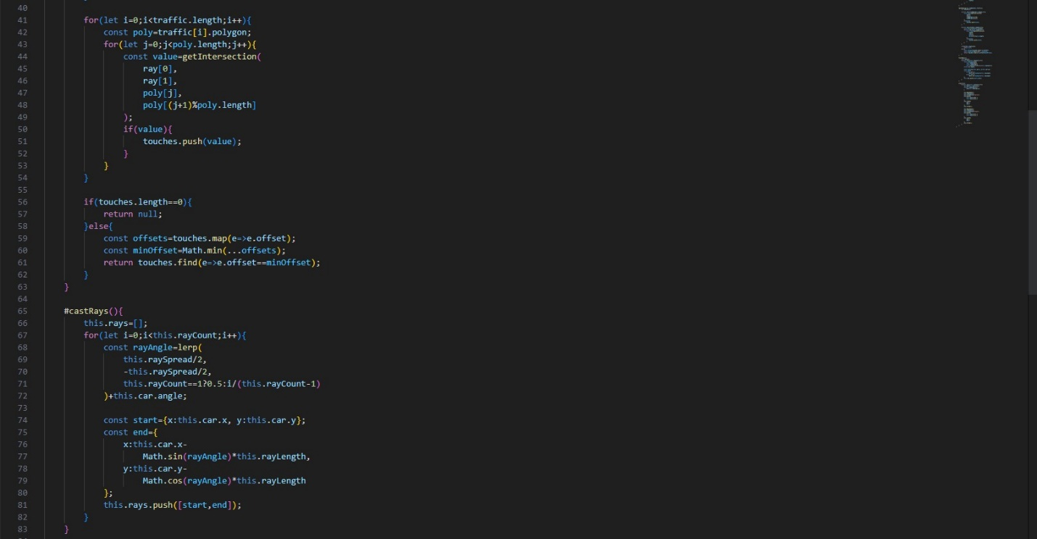

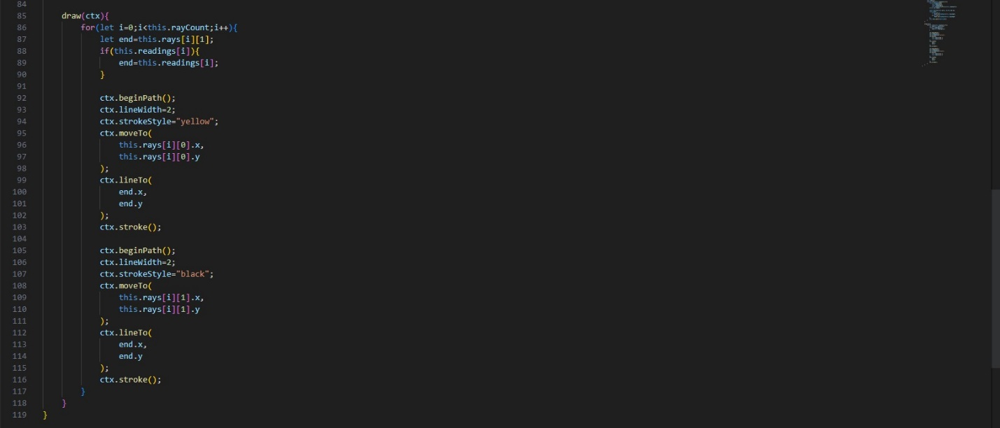

**Collision Detection:**

Checks if the car has hit anything, if so the car is broken.

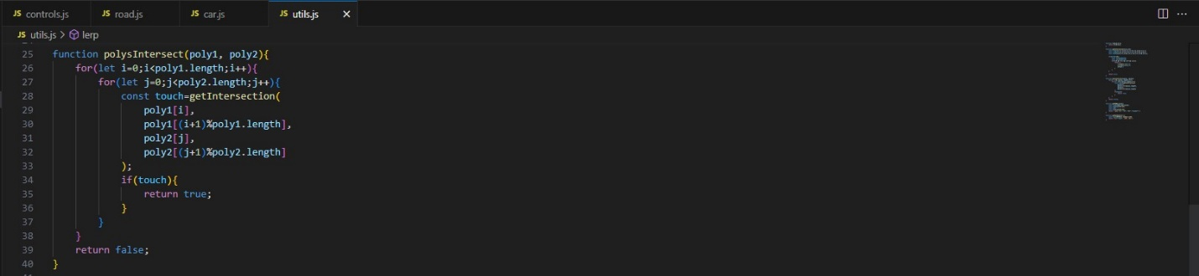

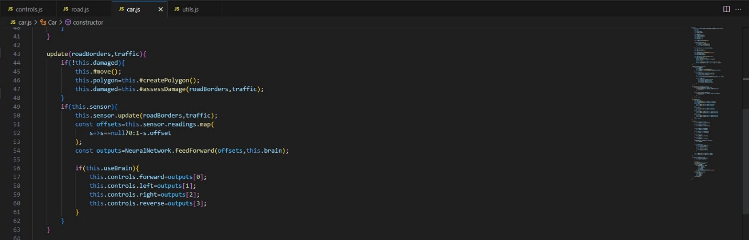

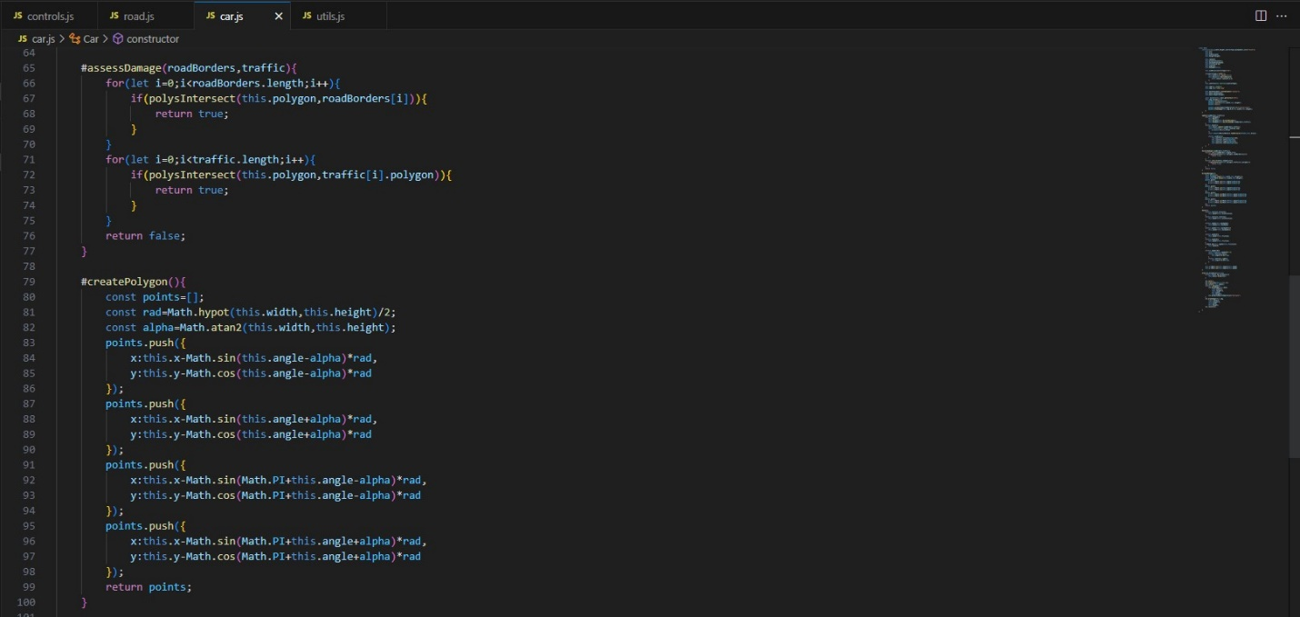

**Simulating traffic**

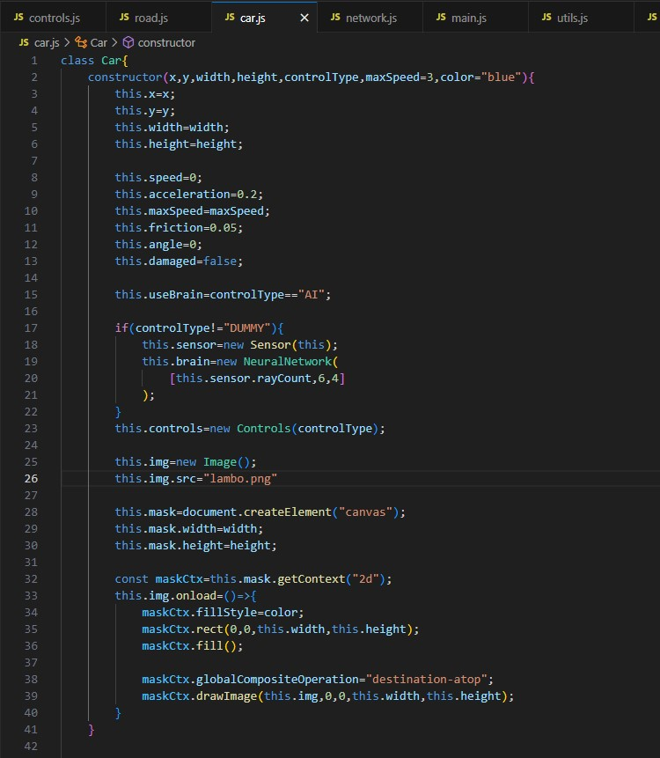

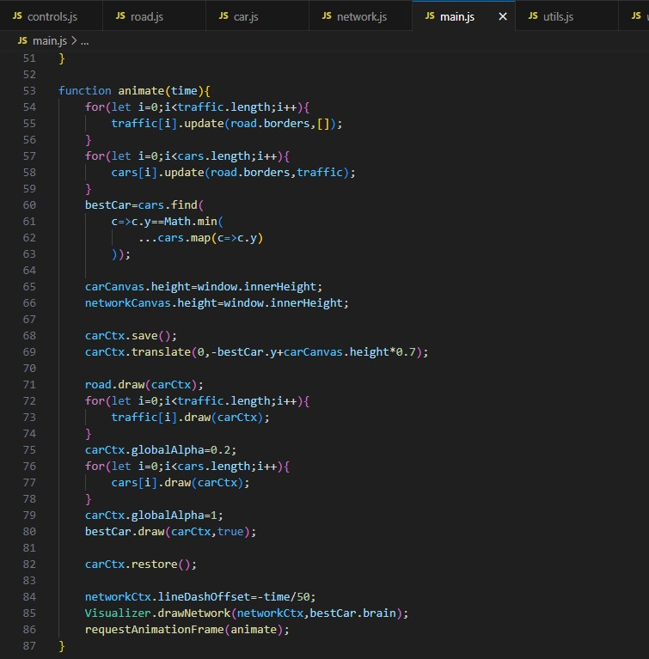

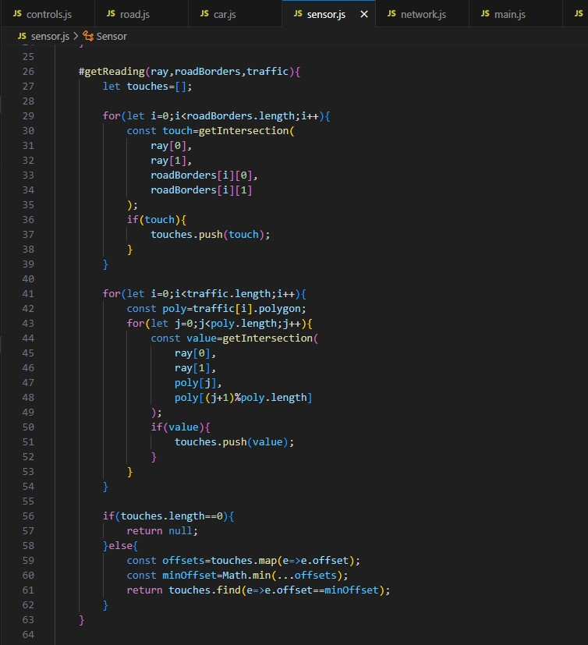

**Neural network**

The neural network used in this self-driving car project consists of multiple levels (layers) of neurons. The structure of the neural network is defined by the NeuralNetwork class, and each level is represented by the Level class. The neural network is initialized with a specific configuration of neurons in each level.

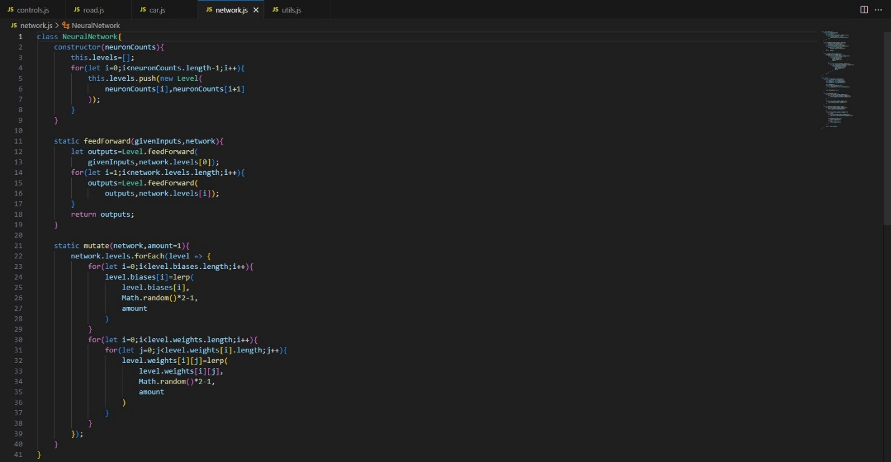

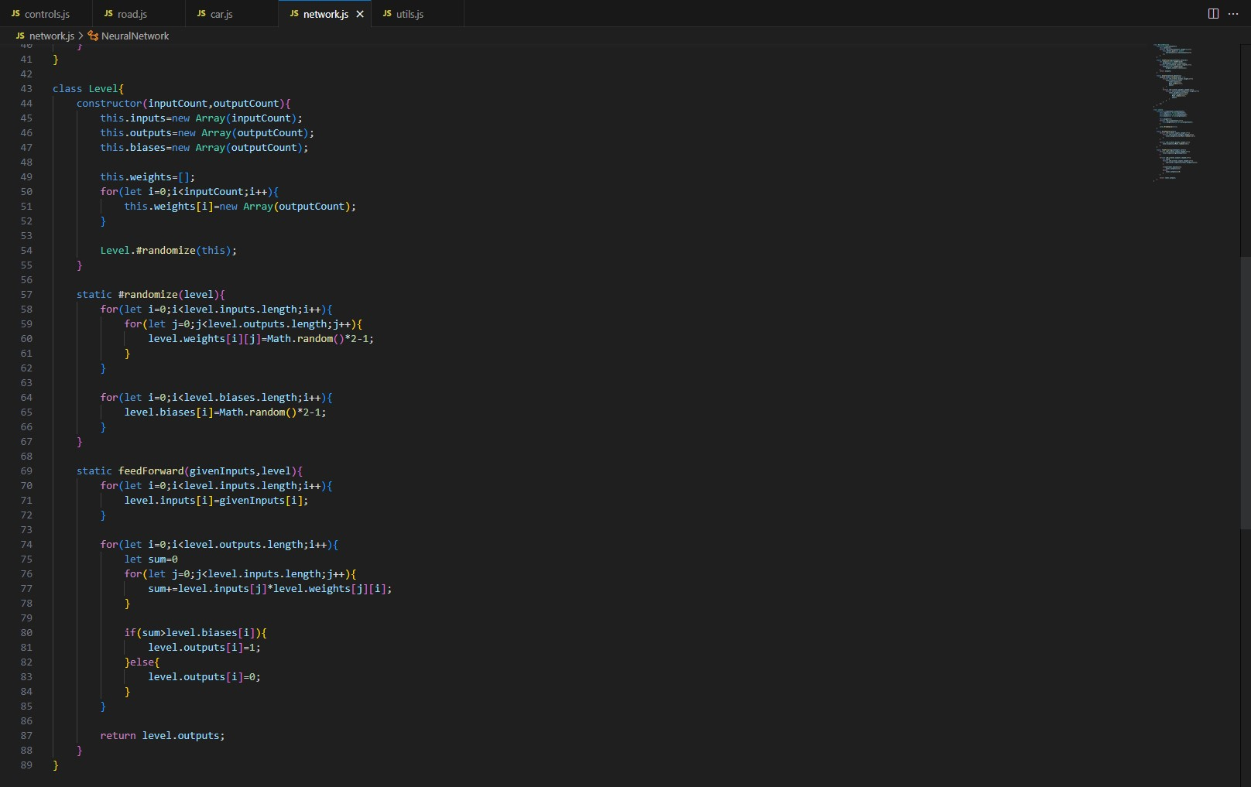

**Parallelization**

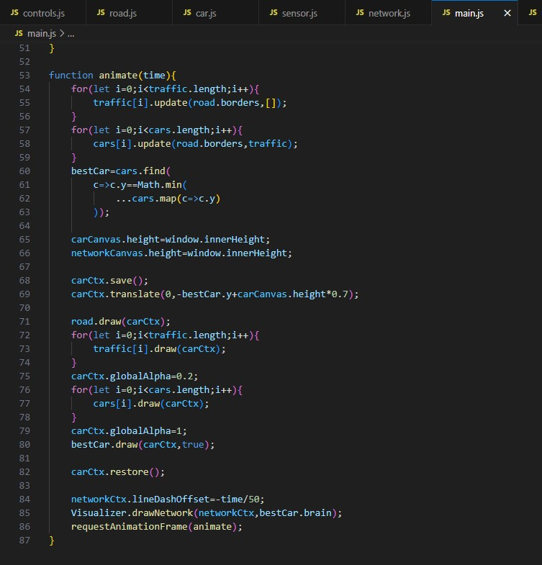

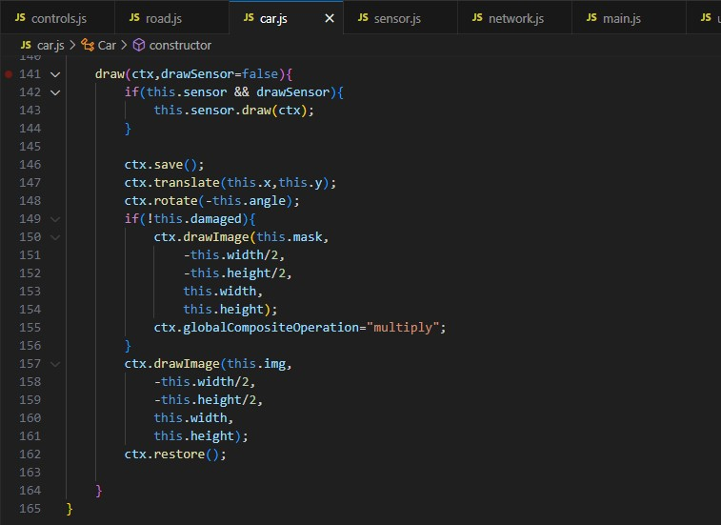

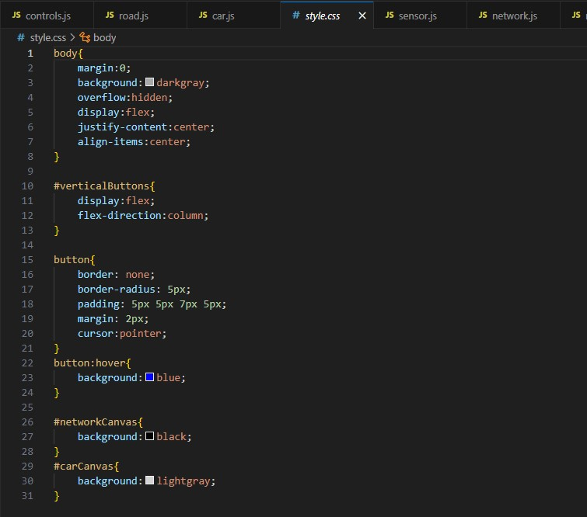

**Genetic algorithm**

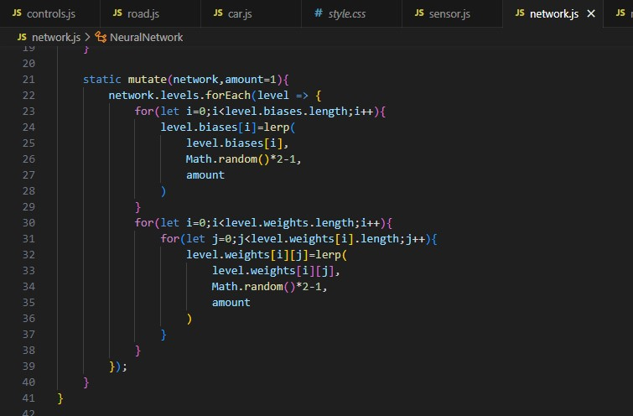

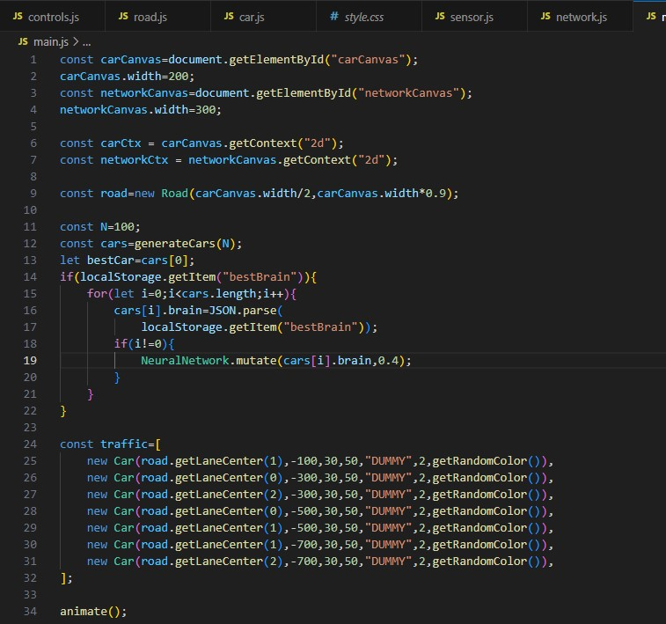

**Visualization**

